**Environment Setup for MRI project**

1. **Install Python 3.6.7**

Go to this link.

URL: <https://www.python.org/downloads/mac-osx/>

Download Python 3.6.7 64-bit MacOS installer. Install python.

1. **Install other Libraries:**

Go to your terminal and run the following command to install required modules:

$ pip3 install numpy

$ pip install Pillow

$ pip install matplotlib

$ pip install nibabel

$ pip install keras

$ pip install tensorflow

$ pip install scikit-image

$ pip install PyQt5

## Install Visual Studio Code and the Python Extension[#](https://code.visualstudio.com/docs/python/python-tutorial#_install-visual-studio-code-and-the-python-extension)

1. If you have not already done so, install [VS Code](https://code.visualstudio.com/).

## Installation[#](https://code.visualstudio.com/docs/setup/mac#_installation)

1. [Download Visual Studio Code](https://go.microsoft.com/fwlink/?LinkID=534106) for macOS.
2. Open the browser's download list and locate the downloaded archive.
3. Select the 'magnifying glass' icon to open the archive in Finder.
4. Drag Visual Studio Code.app to the Applications folder, making it available in the macOS Launchpad.
5. Add VS Code to your Dock by right-clicking on the icon to bring up the context menu and choosing **Options**, **Keep in Dock**.
6. Next, install the [Python extension for VS Code](https://marketplace.visualstudio.com/items?itemName=ms-python.python) from the Visual Studio Marketplace. For additional details on installing extensions, see [Extension Marketplace](https://code.visualstudio.com/docs/editor/extension-gallery). The Python extension is named **Python** and it's published by Microsoft.

[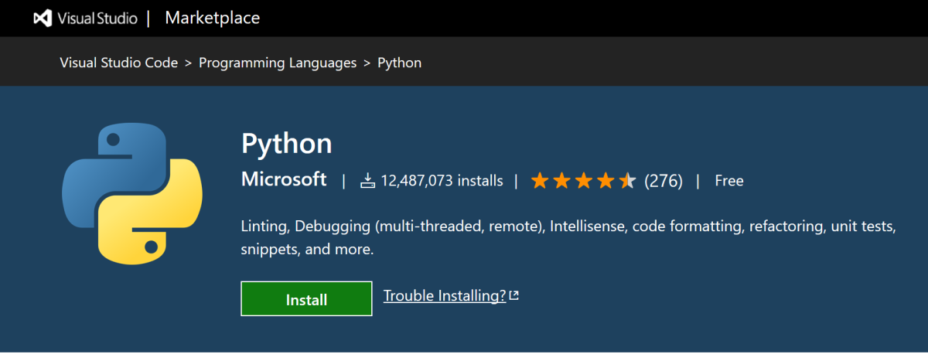](https://marketplace.visualstudio.com/items?itemName=ms-python.python)

**Running MRI project:**

1. Open Visual Studio Code.
2. Go to, **File -> Open Folder** menu.
3. Select “**D:\MRI-Reconstruction\submrine\submrine**” folder and click Open button.
4. Copy the raw images those will be used for training the network in “**D:\MRI-Reconstruction\submrine\submrine\raw_image”** folder.
5. In left panel, right click on the “**MainWindow.py**” file and select “**Run Python File in Terminal**”. This start the project’s main window.

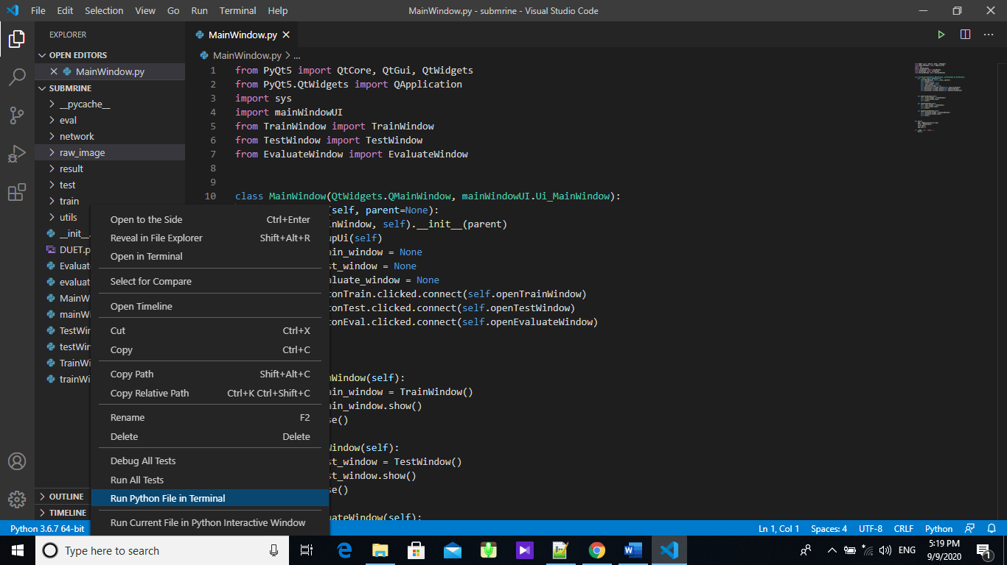

**Download Raw MRI data:**

1. Go to this link: [***http://www.oasis-brains.org/#dictionary***](http://www.oasis-brains.org/#dictionary)
2. From **OASIS Brains Datasets** Select **OASIS-1.**

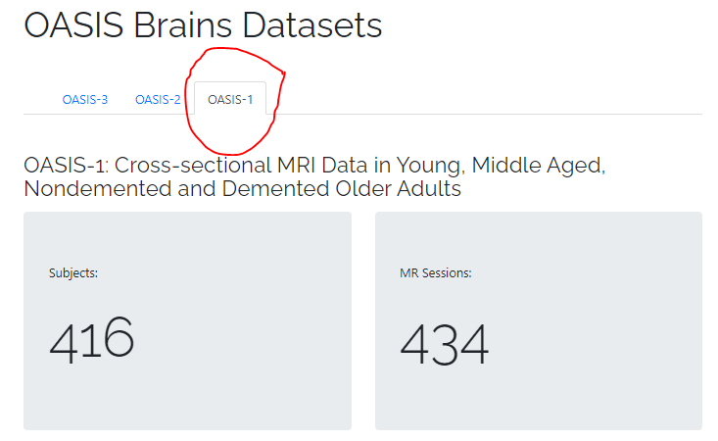

1. Then in **Get Data** select **Download Instructions**.

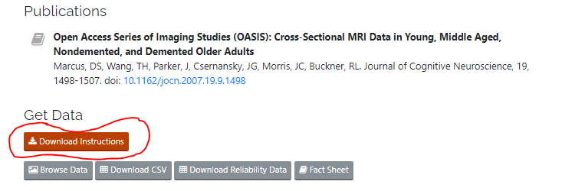

1. From **Raw Data** download compressed folders.

